s./



|  |  |  |  |  |  |
| --- | --- | --- | --- | --- | --- |
| **Ver.Rel. No.** | **Release Date** | **Prepared. By** | **Reviewed By** | **Approved By** | **Remarks/Revision Details** |
| 1.0 | 26-12-20 | Sagar Jadhav |  | Dr. Vivek K and Bhargav N |  |
| 1.1 | 03-01-21 | Sagar Jadhav |  | Dr. Vivek K and Bhargav N |  |
|  |  |  |  |  |  |
|  |  |  |  |  |  |
|  |  |  |  |  |  |

**Document History**

**Contents**

**1 Make Execution in GIT 4**

1.1 Files after execution of Make 4

1.2 Header section of main.o 5

**2 Mini project 6**

2.1 Main logic function 6

2.2 GIT link: 6

# 1 Make Execution in GIT

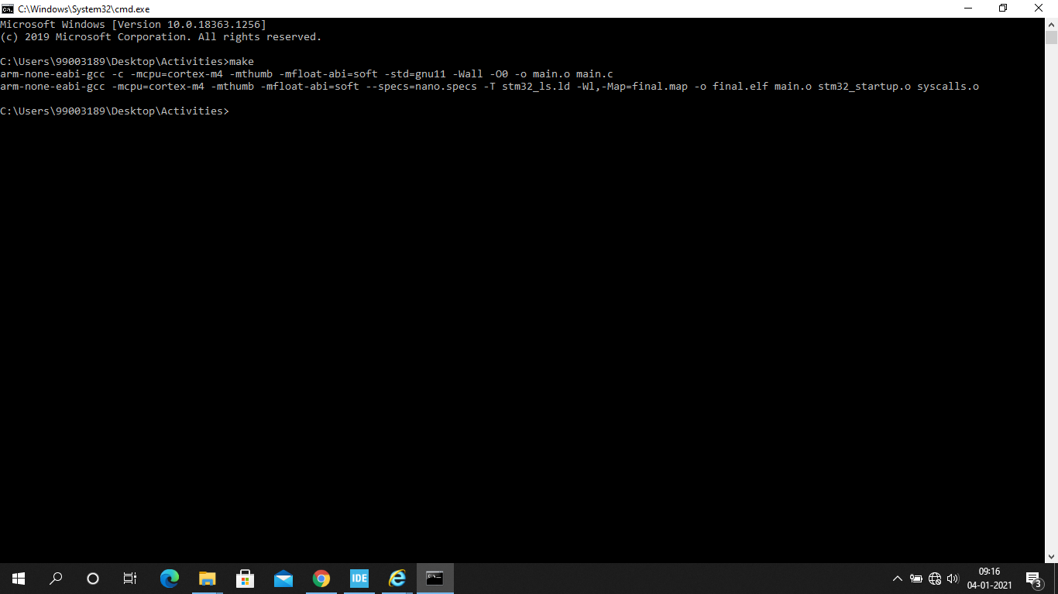

Header section of main.o file

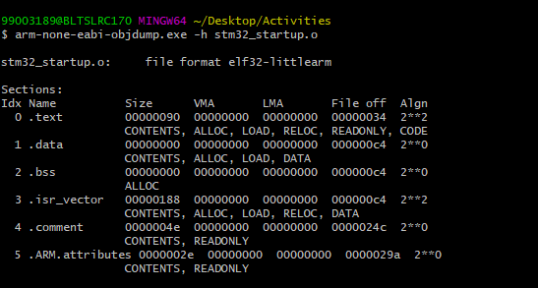

## Files after execution of Make

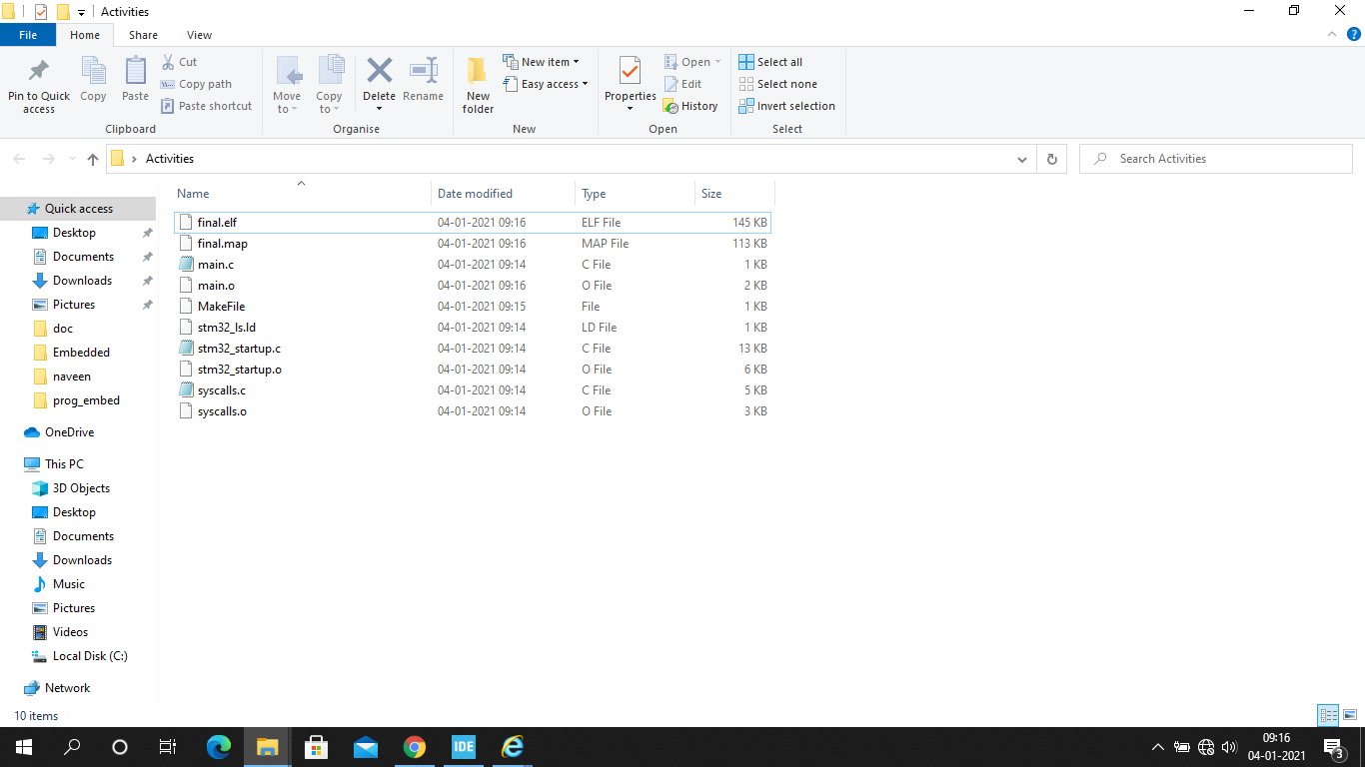

## 2.1 GIT link:

[99003147/EmbeddedC (github.com)](https://github.com/99003147/EmbeddedC)